Skills Workshop: Technical Writing and Presentation

Speaker: Dr. M. Kupferle, Associate Professor, Department of Chemical and Environmental Engineering, College of Engineering and Applied Science
Date: Wednesday, June 20, 2018
Time: 10:15- 12:00PM
Venue: University of Cincinnati, Swift Hall, room 608

Prepared by:
Megan Stafford, Holmes High School, Covington, Kentucky
RET Participant for Project #2: “Energy Storage and Batteries”

This session was given by Dr. M. Kupferle, Associate Professor, Department of Chemical and Environmental Engineering, College of Engineering and Applied Science on Wednesday, June 20, 2018 from 10:15-12:00PM at the University of Cincinnati in Swift Hall, room 608. She currently teaches graduate and undergraduate courses in chemical and environmental engineering. Dr. Kupferle chairs the Environmental Engineering Program and advises the UC student chapter of Engineers Without Borders. Dr. Kupferle recently served as co-PI and Project Mentor for a 3-year summer NSF REU Site as well as the most recent 3-yr NSF RET Site. She is also Co-PI for this new RET grant.

Dr. Kupferle opened her session by verifying the required technical reports and presentations that will be created as part of this RET program and verifying when more detailed information about these items will be received. This transitioned seamlessly into her presentation as it set the stage for Dr. Kupferle to provide the additional information needed for two of the required technical reports: team research report and NSF summary report.

A general outline of the team research report was given. Dr. Kupferle explained each part and gave examples of these parts; specifically, she described keywords as shown in Figure 1. Specific formatting requirements for the cover page, reports, and general page were provided. Dr. Kupferle also reviewed the general formatting guidelines for the main body of the research report and emphasized the correct spacing. Following specific formatting, she reviewed grammatical sentence-level tips concerning verb tenses nouns, and unnecessary words. When writing the team research report it is important to avoid passive voice. Dr. Kupferle gave examples of passive voice and had the audience of RET teachers convert these phrases to active voice. She then described using strong verbs for increased specificity and avoiding turning verbs into nouns for the best quality of writing and comprehension. The final grammatical tip was to avoid burying the main verb. Dr. Kupferle had the RET teachers practice unburying the main verb in groups of 3 and share out their edited sentences. Overall, these formatting and grammatical tips can lead to less convoluted writing with proper revision.

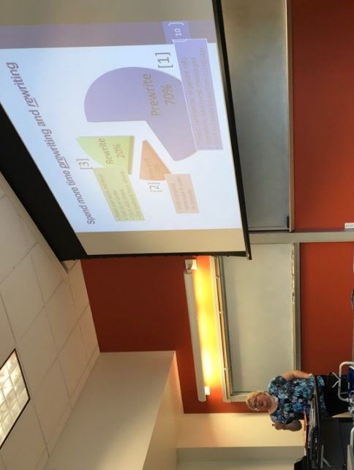  Figure 1: Dr. Kupferle Discussing Keywords | 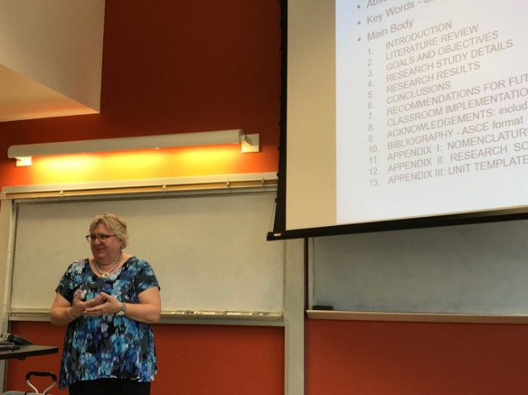  Figure 2: Highlighting Prewriting and Rewriting

The majority of the time spent writing the team research report should be in the prewriting and rewriting. These two stages help to obtain the most well-written report. Dr. Kupferle stated prewriting should compose 70% of the writing time and rewriting should compose 20% of the time. She highlighted actions items to be done in these steps, as shown in Figure 2. During the prewrite it is expected that information is collected, synthesized, and organized in combination with brain storming to lead into the creation of an outline. This outline further helps compose the draft in an ordered manner. Once the draft is written, reading the draft out loud, checking grammar, and obtaining feedback are expected during the rewrite stage. The team research reports will be reviewed by numerous people to help with revisions. Additionally, Dr. Kupferle advised removing unnecessary words and not using jargons or acronyms because avoiding “word salad” can assist with the readers’ comprehension.

Next Dr. Kupferle followed her PowerPoint presentation to discuss tips for writing an abstract and tips on paragraph-scale. These two items help ensure a logical flow of ideas with parallel sentence structure is in place. It is expected for the team research reports to contain figures with proper and consistent citation. She gave an example of inconsistent citation to demonstrate the confusion the inconsistency can generate. The team research reports will also likely contain tables. Placing tables into a report without explaining its context can also create similar confusion. Based upon the information presented within the team research report, numbering equations and defining variables is another mechanism to eliminate reader confusion. Lastly concerning the team research report, Dr. Kupferle reiterated the use of ASCE formatting for the bibliography.

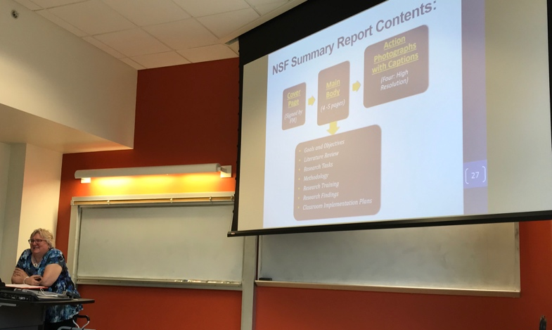
Figure 3: Looking for Hard Vocabulary Words

Dr. Kupferle finished with the team research report details and began discussing the NSF summary report. The NSF summary report will contain a cover page, main body, action photographs with captions, and footnotes. The main body is expected to be 4-5 pages in length discussing the goals and objectives, literature review, research tasks, methodology, research training, research findings, and classroom implementation plans. Much like the team research report, the NSF summary report has additional formatting requirements Dr. Kupferle reviewed. The NSF summary report cannot be written in first person and the footnotes must in Arial font size 9. Also like the team research report, the NSF summary report will use ASCE citations in the footnotes. Dr. Kupferle noted the similarities between these two reports and emphasized the importance of following the different formatting requirements.

Dr. Kupferle ended her workshop by providing helpful resources. The resources provided can assist with ASCE citations, avoiding plagiarism, and reviewing examples of writing as engineering and science students.

