PD: Wiki Session – Create and Personalize Workshop

Presenter: Mr. Dennis Dupps, Technology Resource, CEEMS Grant, UC
Date: Monday, June 18, 2018
Time: 10:30am – 12:00pm
Venue: University of Cincinnati, Swift Hall, Room 608
Prepared by: Adam Mesewicz, Holmes High School, Covington, KY, RET Participant

Mr. Dennis “Denny” Dupps has a long history in both education as well as information technology. He started his education journey by obtaining his bachelor’s degree in Industrial Arts Education and his Master’s degree in Secondary Education. He has a wealth of teaching experience, having served as a technology teacher at Indian Hill High School for over 45 years. serving as the President of the Ohio Technology Education Association , serving as the technology lead for the CEEMS grant and as well as serving as the faculty advisor for the student run Indian Hill Television Network.

In his session today, Mr. Dupps started by introducing the objectives of the session. As you can see in Figure 1, the goal of this presentation was to learn about and then create our own personal Wikis.
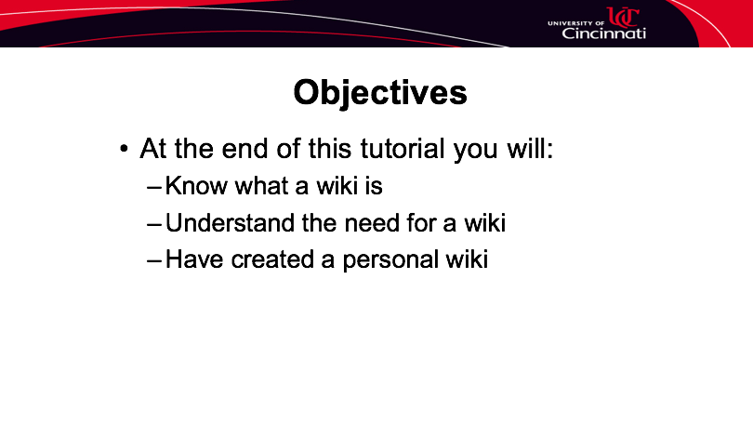
Figure 1: Objectives Listed for this PD

After introducing his objectives, Mr. Dupps went on to discuss the concept of a Wiki, and the reasons why a wiki is instrumental for all RET participants. Among these reasons, which can be seen in Figure 2, Mr. Dupps informed RET participants that their wikis would be used to store unit documents and collaborate with other teachers.

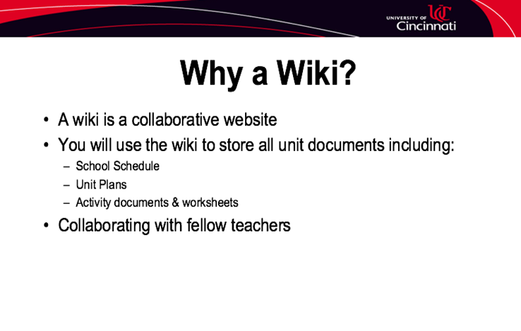
Figure 2: Why a Wiki?

After teaching RET participants about why they were going to be creating a wiki, Mr. Dupps transitioned in to teaching participants how tocreate a wiki. To start, participants used their own Google accounts to create a Google Site. Once created, Mr. Dupps went through the process of setting up our pages to include the content specific to RET.The penultimate portion of Mr. Dupps’s presentation instructed participants on how to modify the wiki page. Here, RET participants were shown how to add pictures, bios and unit documents. Although not all participants were able to update the wiki in real-time, Mr. Dupps instructed participants to work on adding information and if we there were roadblocks to contact him with any questions.

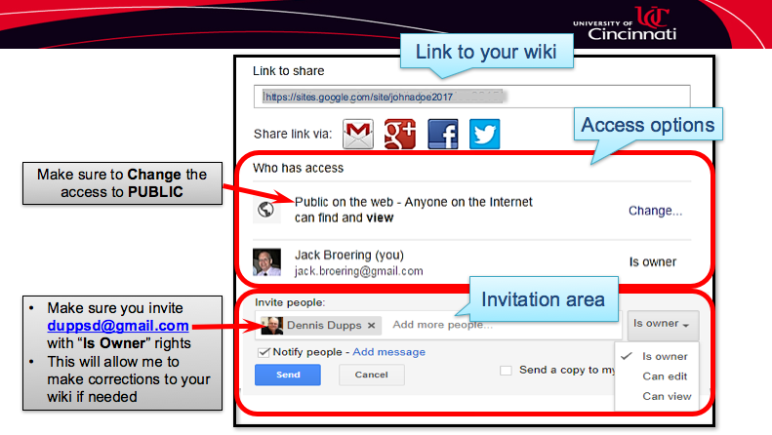
The final portion of Mr. Dupps session covered how to share the Google page. RET participants were asked to make their wiki pages public, so non-RET teachers have access to the units and activities being created this summer. Detailed instructions were given for this step, and can be found in Figure 3.
Figure 3: Sharing a Wiki

