Skills Workshop #1: General Lab Safety Workshop

Speaker: Ellen Elsbernd
Date: Monday, June 11th 2018
Time: 1:00pm - 2:30pm
Venue: University of Cincinnati, Swift Hall, room 608

Prepared by:
Aaron Debbink, Indian Hill High School, Cincinnati Ohio
RET Participant for Project #2: “Energy Storage Devices Based on Three Dimensional (3D) Graphene: Case Supercapacitors and Lithium-Sulfur (Li-S) Batteries.

This session was given by Ms. Ellen Elsbernd, who is the Chief OSHA (Occupational Safety and Health Administration) Compliance Officer for the Office of Environmental Health and Safety at the University of Cincinnati. She has been addressing various safety and health concerns at the University of Cincinnati for over the past 25 years. She is currently working on a special emphasis shop safety and machine safeguarding program. Ms. Elsbernd has two undergraduate degrees in Science Education and Forensic Chemistry, and an MBA in Operations Management. Prior to working in Higher Education, Ms. Elsbernd taught high school chemistry.

Ms. Elsbernd started the session by asking each participant to share their teaching content area and the age of students taught. She also wanted to know which teachers were expecting to work with hazardous materials during their research project. Ms. Elsbernd stated the purpose of the OSHA Hazard Communication Standards was to ensure that individuals had the right to “know and understand the hazardous chemicals in your workplace and how to work with them safely.” Ms. Elsbernd next defined what constitutes a hazardous chemical, items which have either an acute, or chronic effect due to exposure to the chemical. She then summarized many of the various physiological effects and physical hazards.

Ms. Elsbernd next discussed routes of exposure to chemical hazards, particularly through inhalation, skin absorption, ingestion or injection. She discussed that the regulatory limits when considering exposure limits is often higher than what would be advised, and she suggested that participants should aim for exposure that is as “low as reasonably able”. OSHA has both 8-hour exposure limits and short term exposure limits, but some hazardous chemicals are “sensitizers” which can give people adverse health effects from repeated exposure to amounts of the chemical much lower than the regulatory exposure limits. Ms. Elsbernd discussed an example of outgassing formaldehyde.

Next, Ms. Elsbernd shared that safety data sheets are used to communicate the effects of hazardous chemicals, see Figure 1. Safety data sheets detail signs and symptoms of exposure, control measures, accidental release measures, emergency and first aid directions, spill procedures, physical and chemical properties, stability and reactivity, toxicological information, protective exposure limits and other information. Ms. Elsbernd shared that the participant’s responsibilities are to know the location of the principal investigator’s safety data sheets file in the lab and be ready to take those safety data sheets to the emergency room in the event of an accident. Ms. Elsbernd next shared what type of information is included when labeling a container which contains hazardous chemicals and the different types of “pictograms” which identify specific types of hazards, see Figure 2.

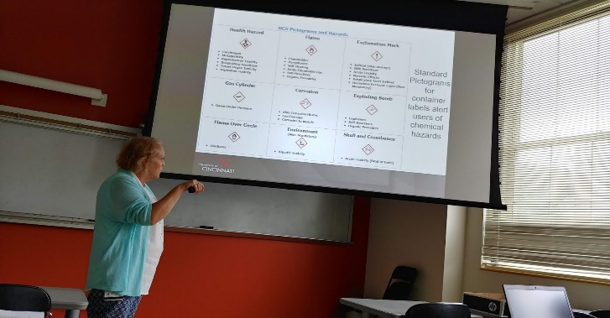  Figure 1: Discussing Material Data Sheets | 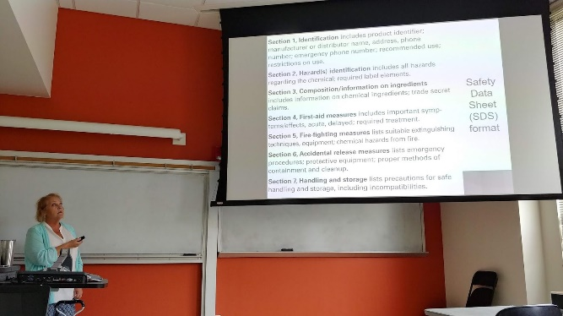  Figure 2: Identifying Pictograms

Ms. Elsbernd next discussed standards for laboratory signage: with the hazard warning diamond the blue diamond refers to health risks, the red diamond refers to flammability risks, the yellow diamond refers to reactivity risks, and the white diamond refers to special hazards which is used nationally by fire departments for identifying risks. She also discussed how the new OSHA identifying numbers were adopted to match international standards, but seemed opposite the convention used nationally by fire departments.

Ms. Elsbernd next discussed how to control exposures. Where elimination is not possible, use a substitute chemical which serves the same purpose. When substitutes are not possible, an engineering control can be used which includes the use of fume hoods. She shared tips for effectively using a fume hood which includes keeping the lab doors closed, adjusting the sash to the lowest level for convenient use, working at least six inches inside the face of the cabinet, keeping the hood free of clutter to eliminate air turbulence, and avoiding the heating of perchloric acid in a regular fume hood, which can deposit perchloric salts in the vents causing it to spontaneously combust.

Ms. Elsbernd next discussed good hygiene and work practices. Participants should wash hands (sing the alphabet), keep flammable materials in approved containers, and use adequate respirators when necessary. The university provides fire extinguishers, eye washers, showers and electric panels when accidents occur. Spills are expected to occur. Make sure to dispose of spill clean-up materials as hazardous waste. Principle investigators should know how to clean up spills, and often labs will have “spill kits” for cleanup.

Ms. Elsbernd then quizzed the participants on proper and improper practices. Example images were shown and participants were asked to identify the illustrated proper or improper practice, see Figures 3 and 4.

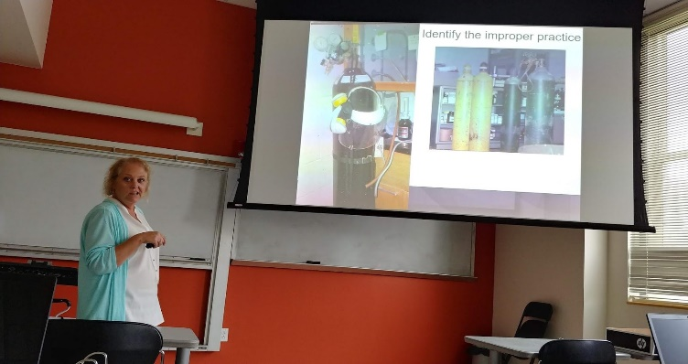  Figure 3: Illustrating Improper Practices | 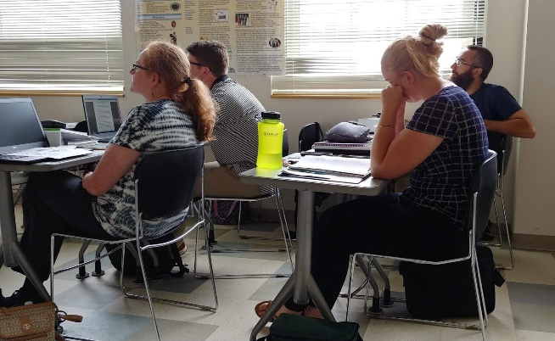  Figure 4: Students Considering Illustration

Ms. Elsbernd finally discussed particular concerns with nanotechnology which may affect two of the program participants. Nano-sized materials remain suspended for days to weeks if released into the air, and some nanoparticles can enter the brain directly by means of the olfactory pathway from the nose. Routes of exposure are similar to other sized materials including inhalation, ingestion and skin penetration. Current accepted controls include source enclosure and local exhaust ventilation. Ms. Elsbernd specifically noted that PPE (respirators) are not adequate protection against inhalation since HEPA filters are only good for micro-sized materials. Ms. Elsbernd finally ended the workshop by answering any remaining participant questions.

