- Workshop on Analyzing and Refining Units (Speaker: Ms. Debbie Liberi, District Coordinator, CEEMS MSP; Date: July 8; Time: 9:00 AM-11:00 AM)
Ms. Debbie Liberi currently serves as the District Coordinator for the CEEMS grant at UC. She earned her BA in Biology at Wittenberg University and a Masters in Secondary Educations from UC, as
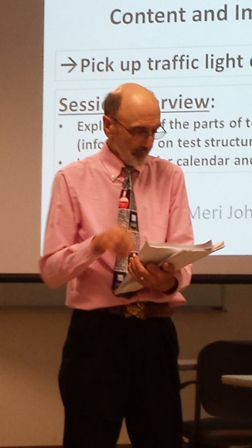
Figure 1: Mr. David Vernot Presenting on Test Specifications
well as a Masters in Library and Information Science from Kent State University. She was a middle school science teacher and high school librarian for 35 years with CPS. From 2000-2010, Ms. Liberi was a National Board Certified Teacher in Early Adolescence Science. She also served as a lead teacher in various mentoring roles for CPS. In addition, Debbie serves as an adjunct faculty in the Teachers College at UC.
To start the seminar, the importance of preparing the Unit for implementation and proper completion of the templates was elucidated. If the Unit is written completely and correctly, other teachers considering using the Unit, the students participating in the Unit and the coaches evaluating the Unit could all benefit. This workshop’s purposes included help creating a better Unit, a discussion of “quality” of a Unit and a reflection on Unit construction habits.
Moving forward, there was a large group discussion about how to use the templates. The audience included CEEMS teachers from Cohorts 2 and 3, RET teachers and coaches. Feedback was elicited about the best way to start a template, the hardest parts of the template to complete and problem areas for both teachers and coaches. Participants agreed it was important to start with the standard being addressed. Problems and difficulties tend to occur with estimating the time of Unit implementation and going back to reflect on Units after they’ve been taught in class.
The rest of the workshop was used to evaluate a science Unit that was written with some problems and successes built in. Working in small groups including teachers/coaches from each of the cohorts, teachers were provided with three tasks. The first task was to identify 5 characteristics of a good Unit template and good activity templates. Responses shared with the large group included (a) organized and concise, (b) the challenge is well defined, (c) meets course standards, contains challenge based learning and the engineering design process, (d) has global relevance, and (e) is written with enough detail that another teacher could implement the Unit after reading it. Next, a 7th grade science Unit focusing on the big idea of cleaning up oil spills was provided to the group. Task 2 and 3 were to look at the Unit and activities to determine what needed to be changed or suggestions for improvement. This task was helpful, because after evaluating somebody else’s Unit, Units that teachers write will probably be of higher quality, because they learned from another person’s mistakes.

