Using Library Facilities at CEAS Library (Speaker: Ted Baldwin, Science and Engineering Librarian; Date: June 20; Time: 4:30-6:00 PM)

Mr. Ted Baldwin was the presenter for the workshop on using library facilities at the CEAS Library. Mr. Ted Baldwin has been the Director of the College of Engineering and Applied Science Library, or CEAS Library, since 2009. He oversees services and staff at CEAS Library, and is responsible for purchasing journals and databases. He has also worked in industry, managing the Research & Development Library at Lyondell Chemical Company. Mr. Baldwin has a Master’s degree in Library Science from Indiana University (with a Specialist’s Certificate in Chemical Information), and BA from DePauw University, with majors in Music and Chemistry.

RET teachers were first introduced to the home library, www.guides.libraries.uc.edu/reu as well as the home page of the library. Mr. Baldwin showed them how to search for articles or summon for subscription articles, books, and journals. He differentiated the various databases and showed how guides are listed under course guides (special programs such as RET). The presenter showed teachers the off campus web access, so they can work from home, the UC library catalog which will search all libraries across UC, how to distinguish which search material might be an ebook, and how to tell if a UC dissertation versus a book is on reserve or available for circulation (CEAS Stacks). According to Mr. Baldwin, books can be requested from on campus books to CEAS or also from OhioLINK (from other universities). He showed RET teachers the Wiley online library and how to do an interlibrary loan request through guides.libraries.uc.edu/ceasebooks.

Among the various databases, Mr. Baldwin recommended crcnetbase.com, from crc press, to help with the research topics. The site illiad.uc.edu/illiad/ for articles is not available at UC or not available through OhioLINK. Teachers can contact him to request an article of interest. The general research databases such as COMPENDEX (Engineering Village) and INSPEC (computer and electrical engineering) are also highly recommended. Specialized data bases such as TRID are specifically for comprehensive transportation searches. The research database Scopus covers a whole broad range. Mr. Baldwin demonstrated how the teachers’ own research topics can be searched, noting key specific terms (for example, monograph represents a book.) Mr. Baldwin looked up Dr. Wei’s article from the journal Bridges on transportation in China. He also showed the teachers a free version of ProQuest and SciFinder (chemical and biological literature) which he recommended for the norovirus research topic. Upon request, Mr. Baldwin can provide temporary log in access to this for the summer.

In addition to all of these databases, Mr. Baldwin recommended FREE resources. Google Scholar covers full text at no cost for students in districts that do not have databases. Google Scholar has no opinion pieces or newspaper articles. RefWorks is a citation management system, a tool similar to the endnote software. And finally, he showed the teachers the site he worked on, digitalprojects.libraries.uc.edu/armstrong/, which provides a presentation of 3d content rotated in Neil Armstrong’s collection of letters and photos as an astronaut and instructor at UC.

The presenter was able to introduce many techniques to access the library databases which will equip them to complete the REU/RET Research exercise due Thursday, July 3rd. This exercise can be found on http://guides.libraries.uc.edu/reu-exercise. RET students are encouraged to contact him or Mr. Jim Clasper for assistance with any research questions. A picture of Mr. Baldwin presenting the workshop is shown in Figure 1.
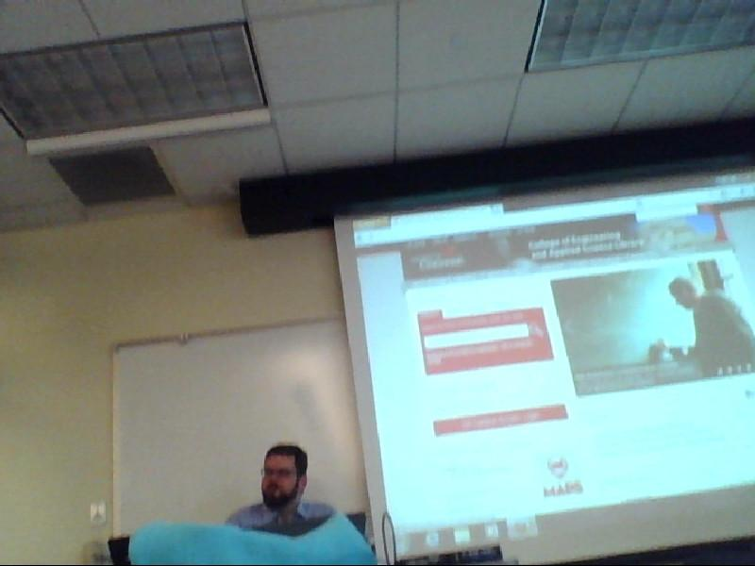
Figure 1: Ted Baldwin Presenting How to Access Campus Databases

