Unit Lesson Template Planning and Wiki Creation (Speakers: Ms. Julie Steimle, Project Director, Mr. Dennis Dupps, Technology Associate, and Mr. Jack Broering, Resource Team Member for CEEMS MSP; Date: June 23; Time: 1:00-4:00 PM)
The purpose of these sessions is to familiarize the CEEMS and RET participant teachers with the standard set of planning documents and a standard method of publishing the products of our efforts – the unit plans to a web page using a wiki site. The standard format for all unit plans, lesson plans and activity plans will facilitate the use and adoption of these plans by others in the CEEMS and RET Programs.
Ms. Steimle began the session with an introduction to the various parts of the Unit Plans. In particular, Ms. Steimle used Jim Shad’s and Kathleen Jones’ Unit Lesson Plans to call attention to specific portions of the Unit Plan.
The first portion of the unit plan was the Justification for Selection of Content. This portion should be in harmony with the course standards and should focus on standards where students past test scores demonstrate lack in mastery and require intervention to succeed in the current course.
The ACS portion of the plan refers to Application, Career, and Societal impact, as pointed out by Ms. Steimle, who went on to discuss the importance of these in making the unit relevant to the students in the class. RET and CEEMS teachers must use each of these as a means to form a connection with the students and bring the students to own the project through Challenge Based Learning.
Cross-cutting and Hierarchical Unit portions of the Unit Plan document were highlighted as well as a way of connecting to other subjects either within the same grade level or at levels above and below. By doing this, these lesson plans are more easily adapted for use by other teachers in other disciplines or grades with minor effort.
The Misconceptions section is important, according to Ms. Steimle, to safeguard that students who are otherwise capable of grasping the content, are guided away from the most prevalent pitfalls associated with the learning topic addressed within the Unit Plan.
Ms. Steimle pointed out the importance of making a plan for differentiated learning among students since some may finish well before others and continued engagement is important throughout the Challenge Based Learning and Engineering Design Process used to solve the challenge.
Finally, the Reflection section should be as specific as possible in identifying those portions of the lesson that can be improved or replaced to make a robust and meaningful Unit Plan.
This review of the various sections of the Unit Plan was reinforced through a scavenger hunt for information about each section of the Unit Plan. The picture included in Figure I.21 below shows Ms. Steimle making her presentation.
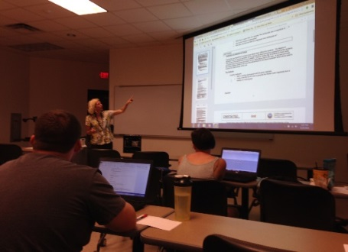
Figure 1: Julie Steimle Reviews Components of the Unit Template
Mr. Dupps and Mr. Broering presented the steps necessary for each student to create a website that would serve as a repository for all CEEMS and RET documents from each member’s Unit Plans. Prior to doing this, Mr. Dupps explained that the purpose of such an endeavor is to improve efficiency in the use of use of these documents by RET and CEEMS teachers as well as by the support team members. Going further, he commented that the documents are a set of tools that the teacher and the CEEMS and RET resource staff will review and revise in a collaborative effort to make each Unit Plan as robust as possible.
Each teacher then created a unique website using Google Sites and customized that site with their picture, their school name, and biographical information. Each member was instructed to create folders under their Home page labelled Unit 1 through Unit 5 and then create a Schedule folder as well. A view of the computer screen shot of the folder to be completed by each teacher during the session is displayed in Figure 2 below.
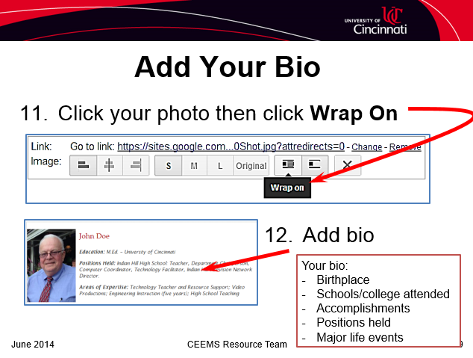
Figure 2: Screen Shot of Wiki Creation
Each teacher was then guided to link a YouTube video in such fashion as to minimize the space used by the site. This involved Mr. Dupps showing how to upload only a link to the video instead of the entire video. In ending his portion of the presentation, Mr. Dupps walked participants through the process of sharing their website with the general public.
Mr. Broering then took over the presentation with a stepwise description for creating a set of files for a Unit Plan that automatically adheres to a file name convention utilized throughout the CEEMS and RET program. The steps involved opening a spreadsheet and entering the teacher name and the title of the unit. Teachers were then prompted to click a button in the Excel spreadsheet that executed a macro that automatically generated all the necessary files for that Unit Plan. Each teacher was then directed to upload their unique files to their particular Unit 1 folder on their website.

