Technical Writing and Presentation Workshop (Speaker: Director for Engineering Outreach, College of Engineering and Applied Science and Professor, Department of Biomedical, Chemical and Environmental Engineering; Date: June 27; Time: 3:30 -6:00 PM)
This session was presented by Dr. Anant Kukreti. Dr. Kukreti is Director for Engineering Outreach for the College of Engineering and Applied Science and Professor in the Department of Biomedical, Chemical and Environmental Engineering. He joined UC in August 2000 as the Head of the Department of Civil and Environmental Engineering (CEE). The workshop was held as a round table discussion session.
Dr. Kukreti introduced the topic for the workshop and emphasized the requirement to use the active voice because the author is building on the work of others. Technical writing/research work is often funded by federal agencies or private organizations. The final project must meet the need of funder and there are standard templates for submitting reports. RET participates will follow the template provided to gain that experience. If publishable material comes out of the research work produced through the RET program, the authors must follow the format required by the journal. Journals have fixed formats and submissions will be returned and not reviewed until it is in the correct format.
Dr. Kukreti clarified that the research project report will be a team report with individual contributions from teachers in regards to how they will implement the research in their classroom. The individual portion is to be in narrative form. The report will include an appendix with the Units of instruction created by the teachers.
Dr. Kukreti continued with an overview of format to be used for the research report accompanied by a handout which clearly the format to be used to the team research project and the final NSF Summary Report. A discussion of importance of the abstract being meaningful followed. Dr. Kukreti explained that the abstract is one of most important ways of disseminating the research. He then asked who had experience with report/technical writing. Participants shared their experiences. Dr. Kukreti used the participant’s experiences as examples for rules and formats for technical writing and document submission.
Dr. Kukreti continued to examine each aspect of the format using the handout. He explained that Arial font is to be used for all reports and PowerPoints because letter thickness size is the same throughout. He provided additional materials to address the abstract with the handout “Science Project Abstract: Guidelines.” Dr. Kukreti shared that the abstract should be part of the first biweekly report generated and that the abstract will be edited and refined as the research progresses. For preparing the abstract, he suggested to limit the abstract narrative to 150 words minimum and 200 words maximum, and organize it as follows:
  - One general statement of the research field to set up research project context. (Background)
  - One sentence describing your specific research project. (Your Project)
  - One sentence describing how the research project will provide new information and advance the field of science or engineering. (Intellectual Merit)
  - One sentence describing the specific question or hypothesis you will be exploring in your research project. (Question of Hypothesis)
  - Describe what models and methods will be used to study the research question or hypothesis (Models and Methods)
  - Describe what specific results are expected and how you will analyze and interpret the results in order to test your hypothesis or answer the question. (Data Collection and Analysis)
  - What scientific or engineering conclusions do you expect to drawn at the completion of your research project? (Outcomes and Conclusions)
  - Explain how the results you expect to obtain will shape the field of research to which your research project applies. (Broader Impact)
  - Describe how your results will be disseminated to others outside your specific research group. (Broader Impact)
A discussion of the placement of figures and text and use of page space followed for the team research report writing along with other helpful tips for technical writing. Format for typing and numbering section, sub-section and sub-sub-section headings was discussed, and not subdividing the section sub-headings beyond sub-sub-section was suggested. Text should be running text with figures and tables inserted either on the same page where it is referenced first time if it can fit on that page or at the top of the next page. Title for figure should be placed below the figure while the title for a table is placed above (participants were provided with examples). Tables should be avoided to be divided between pages, if possible. Insertion and numbering of equations in the text was explained with examples. It was emphasized to define a symbol immediately the first time it appears. Create nomenclature list simultaneously to prevent the reuse the same symbol. Dr. Kukreti provided examples of referencing literature citations in the text and listing them in a bibliography. The literature review should focus on articles that pertained to the research topic. He gave the tip to find key articles that are referenced by other articles and to use articles provided by the GRA. Dr. Kukreti provided helpful hints for cutting and pasting tables and figures into the report as follows: make the text bold and increase font in original then cut and paste.
Finally, Dr. Kukreti provided specific suggestions for creation of the Title Page and Table of Contents with an example for each. The participants were allowed the remaining time to begin writing in their groups.
The Technical Writing Workshop provided the participants with the opportunity to became familiar with the components and the format of the RET research report and the NSF Summary Report. Clear expectations and examples were provided along with handouts that will guide the writing process. Participants were able to ask questions and were provided with answers. A picture of Dr. Kukreti presenting the workshop is shown in Figure 1.
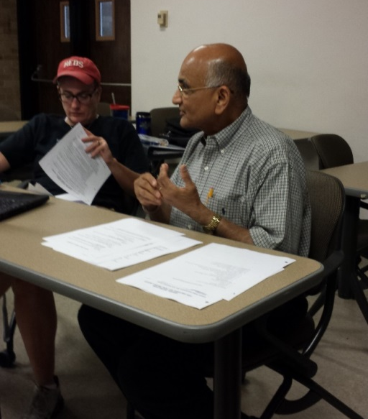
Figure 1: Dr. Anant Kukreti Answers Participants’ Questions About Writing the Report

