Research Poster and Video Sessions 1-4 (Speakers: Mr. Denny Dupps, Technology Associate and Ms. Pamela Truesdell, Resource Team Member, CEEMS MSP; Dates and Times for Four Sessions: July 10, 2014 from 9:00 to11:00 AM, July 14, 2014 from 11:00 AM to 12:00 PM, July 17, 2014 from 9:00 to 10:30 AM and July 24, 2014 from 9:00 to 10:30 AM)
This professional development workshop was presented as a 4-part series, with each session building on the material taught in the previous session relating to scientific poster and video production. The first session was given by Mr. Denny Dupps and Ms. Pamela Truesdell, on Thursday, July 10, 2014 from 9:00 to11:00 AM at the UC’s Zimmer Hall, Room 414. The second to fourth sessions were given at the same location by Mr. Denny Dupps on Monday, July 14, 2014 from 11:00 AM to 12:00 PM, Thursday, July 17, 2014 from 9:00 to 10:30 AM; and Thursday, July 24, 2014 from 9:00 to 10:30 AM, respectively.
Ms. Pamela Truesdell earned a BA and MAT in History, and a BS in Education from UC, before becoming a teacher in Cincinnati Public Schools for 30 years. She served two years at the NSF as an Albert Einstein Distinguished Educator Fellowship program, and currently she serves as a member of the Resource Team for the CEEMS MSP Program at UC. Ms. Truesdell led the portion of the first session that related to poster creation, mentioning that although a template was provided, the teachers should feel free to modify it to make it more attention-grabbing. Edit ruthlessly (less words are better, use bullets, phrases vs whole sentences), include pictures (high resolution, use clip art appropriately, fewer, but bigger pictures), and make sure that the title of the poster highlights the poster’s theme, were just some of the suggestions that Ms. Truesdell provided. After walking through the procedure for creating a poster and detailing every component that needs to be included, she emphasized the importance of having an elevator pitch prepared when showcasing the poster. One word of caution that she shared, however, was to be careful to not reveal too much information to the students relating to the specific Challenge that the students will be attempting to create a solution for during the upcoming school year. The idea behind Challenge Based Learning (CBL) is that the challenge is essentially created by the students. The picture in Figure 1 below shows the poster template introduced by Ms. Truesdell.
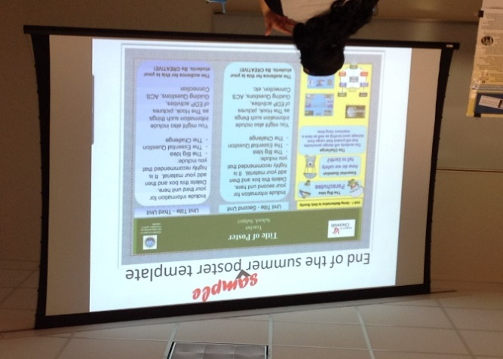
Figure 1: Ms. Pam Truesdell Introduces Techniques for How to Create the Summer Poster
Following Ms. Truesdell’s instruction on poster creation, Mr. Denny Dupps provided brief instructions for creating a video to highlight the teachers’ units. Mr. Dupps also works with the CEEMS program, serving as the Technology Associate. He earned a BS in Industrial Arts Education at Morehead State University and a Masters in Secondary Education from UC. Although he is still employed there part-time, Mr. Dupps taught technology at Indian Hill High School for 45 years. Due to time constraints, Mr. Dupps provided the teachers with a short introduction to video creation, then showed them how to access his tutorial videos so that they could watch the videos and practice some of the basic actions prior to the second video session. He stressed the power of using a student testimonial in the video, advising the teachers to ask the student each question and have them repeat each question before answering. Additionally, he assigned each of the teachers the homework of creating a brief, one-slide video in PowerPoint, complete with a voiceover.
Mr. Dupps also provided three additional sessions for video creation. In each session, he identified a specific focus. In the second video session, Mr. Dupps focused on creating a video in Movie Maker, rather than just in PowerPoint. He walked the teachers through the use of Movie Maker and had them create a mini video as he provided instructions step by step. This method for teaching how to create a movie in small, gradual steps was very effective and really helped to alleviate the stress. In the third video session, Mr. Dupps taught the teachers how to make longer videos in Movie Maker, add pictures, add captions, and add animations. In the fourth and final video session, he demonstrated various ways to add music and other auditory features to videos. The picture in Figure 2 shows a video creation session in progress.
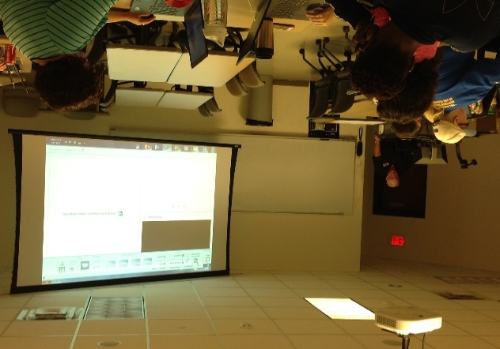
Figure 2: Mr. Denny Dupps Demonstrates How to Use Movie Maker

