Modeling Engineering Design Process (Speakers: C. J. Dicks, CEEMS Teacher, Kevin Metzger, CEEMS Teacher, and Dr. Rob Rapaport, Resource Team Member, CEEMS MSP; Date: June 18; Time: 1:30 - 4:30 PM)
This session was presented by Mr. Kevin Metzger, Mr. Christopher (CJ) Dicks, and Dr. Rob Rapaport. Mr. Kevin Metzger is a second year teacher at Milford High School and currently teaches Geometry (Math II) and Pre-Calculus. He is also a Cohort 2 participant in the CEEMS program. Mr. Christopher Dicks is a sixth year teacher of seventh grade science at Delhi Middle School in the Oak Hills Local School District. Dr. Rob Rapaport is a retired Environmental Engineer and Product Safety and Regulatory Manager from Procter & Gamble with 30 years of industrial experience. He earned a Ph.D. in Environmental Engineering and Chemistry from the University of Minnesota and BS and MS degrees from Rutgers University. He currently works as a Resource Team Member of the UC CEEMS program and volunteers with several local organizations including the Green Learning Station.
Dr. Rapaport opened the session with an agenda and a video from PBS Learning Media titled “What is the Design Process?”. The video provided the key items involved in the engineering design process (EDP) and interviews with engineers sharing how each step is used in solving real world problems.
Dr. Rapaport emphasized steps of EDP using the flow chart shown in Figure 1 on next page. He explained that EDP can be presented and used in different ways. He spoke specifically about the following aspects of EDP: identify the design challenge, engineers research and brainstorm, cost and benefit analysis, and design constraints. The acronym SAFE: Safety, Aesthetic, Function, Economics was offered by Dr. Rapaport as a means of evaluating designs.
He elaborated on each of the following aspects of the EDP: design a solution as part of “identify and define;” research and brainstorming are used to “gather information” and to offer viable solutions as part of “identify alternatives;” ideas are drawn out and evaluated a model is selected as part of “select best solution;” a prototype is built and tested and evaluated to see if it solved the problem as part of “evaluate solution;” then in a quest to further improve or optimize a redesign is done as part of
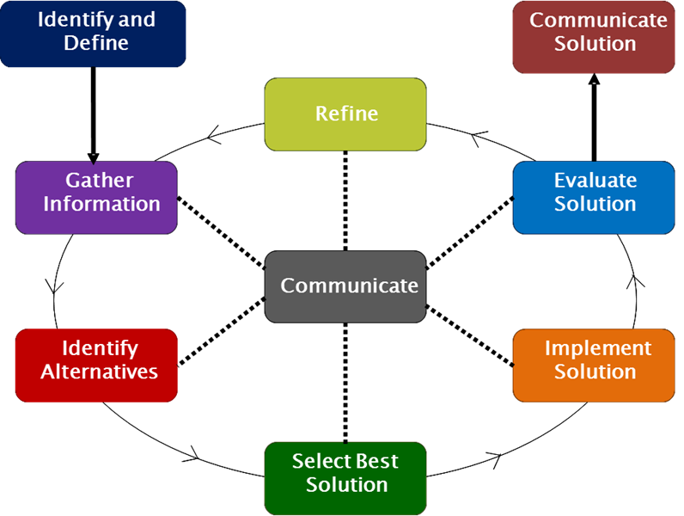
Figure 1: Engineering Design Process (EDP)
“select best solution;” a prototype is built and tested and evaluated to see if it solved the problem as part of “evaluate solution;” then in a quest to further improve or optimize a redesign is done as part of “refine” cycle following the previous steps. Findings and results of every step, besides the final “best” solution are “communicated.” Dr. Rapaport shared concerns associated with the build of the design. Where will the materials come from? What skill sets are required? Engineers make evaluations throughout the process and steps can be taken to address the challenges.
Dr. Rapaport shared that he is a member of Engineers without Borders and is the president of the local chapter. The chapter is working in Uganda with a school operated by the sisters of Notre Dame. There are 500 students. Half the population of Uganda is less than 15 years old due to the prevalence of AIDS. The average life expectancy of a Ugandan citizen is 54. The challenge at hand is the need for a safer way to cook due to the dangers of ventilation, and the source of fuel, wood, is becoming scarce. The project was presented using EDP.
The Big Idea was clean energy in the third world. The challenge was, can bio waste be used to fuel kitchen to cook for 500 students? The sub challenge was to identify what was needed. The process included looking at design options and alternatives. A design was chosen and an anaerobic digester was built. The digester provides methane as a clean burning fuel source through anaerobic respiration from methanogens contained in an oxygen free environment and provided with animal waste and plant material as an energy source. Dr. Rapaport explained that the process for building the digester was rushed because the Cincinnati Zoo requested one for the Uganda exhibit. He emphasized the importance of documenting and communicating work for the purpose of reconstruction.
Dr. Rapaport ended his portion of the presentation by summarizing the EDP and how it was used in designing the project for Uganda.
The second portion of the session was presented by Mr. Christopher Dicks. He began by sharing his experience teaching using Challenge Based Learning (CBL) and Engineering Design Process (EDP) and warned that projects will take longer than anticipated. He introduced the first steps of the process as Identify and Define. The lesson he shared with the audience focused on limited water availability. Mr. Dicks shared questioning techniques used to lead kids to think that they chose the challenge on their own. The problem presented was that landfill liners used to prevent groundwater contamination cannot be made from one piece of material instead many pieces must be used together. The challenge is to design a landfill liner from multiple pieces of material that prevents leaks.
Mr. Dicks explained that his students work independently to gather information, take notes and design at least one solution. After individual research is completed the students work as a team and share information. Students speak one at a time followed by time for questions. Mr. Dicks gave the following suggested schedule: Day 1 research, Day 2 sharing and taking notes from each other, the teams have 3 design options due by the end of the class. The rules of engagement are set by the teacher. Teams are instructed to select the best solution. He warned that students struggle with choosing someone else’s design and offered the option that teams take elements of each design and come up with final design. Finally teams get their chosen design approved and start the challenge activity.
The audience members were placed in teams and given the packets Mr. Dicks provided his students and are presented with the same challenge. He explained that his project ends with his students building a landfill. The activity he shared with the audience is one that leads to the larger challenge. Mr. Dicks warned that if teachers chose to use a challenge or activity found online that they should change something about it so that students can’t just go home and google the answer.
Each group was given the following materials:
1 plastic tub
1 plastic basket
1-50 ml graduated cylinder
1- 2 cup measuring cup
1 funnel
12 inches of masking tape
5- 2 by 10 inch strips of trash bag
Pair of scissors
1 ruler
The challenge is to create a model of a land fill liner to be placed in the hands of a group member, as shown in Figure 2 below. 200 ml of water is to be poured into the liner and held for 1 minute. The amount of water in the liner is to be measured. Redesign and retesting will follow. Teams completed the activity then shared information.
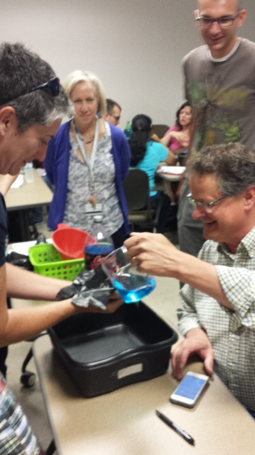
Figure 2: RET Teachers Working on Mr. Dicks’ EDP Activity
Mr. Dicks shared helpful hints in the classroom like assigning jobs and when faced with behavior issues. Or with struggling teams, the teacher can send a “spy” to jump start the team. Suggestions for guiding questions to help the teams share results include: What was your result? What was your design? What would you change? Teams are then given time to redesign after sharing out and the process starts over again.
The final portion of the session was presented by Mr. Kevin Metzger. He shared that he teaches CP Math 2 (10th grade) at Milford High School in a Co-Taught Class that includes 12 students per class all with IEP’s. He explained that he has adjusted EDP to the students and his style of teaching. This past school year he taught 3 Units with EDP. The final Unit was mousetrap cars based on linear equations.
Mr. Metzger explained that his students will measure distance versus time then use excel to plot distance over time and find slope. He prepared students for the challenge with a tennis ball drop activity so they can gain experience with 2 variables. He reviewed EDP with his students using EDP flow chart, as shown in Figure 1.
Mr. Metzger explains that he does not present the challenge right away. He gives his students a bag of supplies and lets them “tinker” for 10 to 15 minutes with the pieces available. After tinkering students are presented with EDP again and the challenge: build a car that is powered by a mousetrap.
Audience members were put into teams of 5 and provided with the following materials:
One 12 inch piece of wood
Four CDs
Rubber bands
Two axles
Nuts/washers
Tape
Three mouse traps
String (arm’s length)
The teams were given 5-10 minutes to tinker. More nuts and washers were made available upon request. The constraint given was: car must go 5 feet with materials on hand.
Mr. Metzger reviewed the 8 steps (besides communicate) of the EDP diagram and how each applies to the problem at hand. Teams found that getting the cars running took more time than estimated and it is reiterated that teachers need to be flexible with pacing lessons. He leads a discussion of why rubber band is needed versus just using string. Mr. Metzger used one groups design to point out what was strong about the design and shared information about student projects that were successful. He strongly recommends requiring students to keep notebooks with ideas and designs. The picture in Figure 3 below shows Mr. Metzger’s activity in progress.
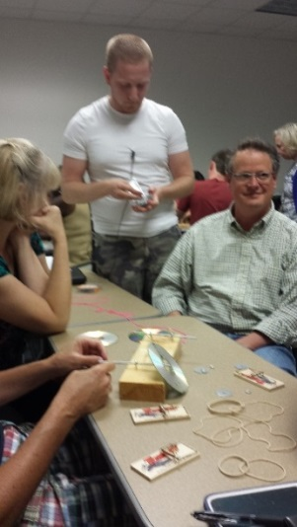
Figure 3: Mr. Metzger’s Activity in Progress

