Engineering Research and Education Workshop (Speaker: Mr. Eugene Rutz, Eugene Rutz, Academic Director, College of Engineering & Applied Science, University of Cincinnati: Date: June 30; Time: 1:00– 2:30 PM)
The session opened with introductions of Eugene Rutz. Eugene Rutz, MS, PE is an Academic Director in the College of Engineering and Applied Science at the University of Cincinnati. Mr. Rutz has oversight of the combined Bachelor's and Master's programs, the Master of Engineering programs and the collaborative program with regional high schools.
To begin the session, Mr. Rutz asked for a discussion about the term STEM. He believes that with the term’s increased use, the meaning of the acronym has gotten lost. Rather than taking each of the fields of study in and of itself, Mr. Rutz sees STEM as an integration of Science, Technology and Math concepts to produce things that are useful (Engineering).
The focus of the presentation then shifted into Engineering as a career choice and the education necessary, with an obvious focus on the programs available at UC. The field of engineering has excellent career possibilities. There will be a lot of jobs available because there are and always will be problems that need to be solved. The Bureau of Labor Statistics project that civil engineering, as a career, will show 20% job growth over the next 20 years, with other engineering careers following with a 9% growth. Students who want to solve problems or help people should be steered to investigate a career in engineering.
High school students who want to apply for an engineering college at a major university needs to schedule their high school coursework appropriately. They should take four years of math, including Pre-Calculus and three years of science, including a year each of chemistry and physics. The average ACT score of students admitted to UC’s Engineering program has been a 29 and the average score of Engineering Technology students was a 24. Mr. Rutz emphasized that it is important for incoming engineering students to have a complete mastery of algebra skills. When students enroll in UC’s program, their costs will include $11,000 for tuition/fees and around $11,000 for room/board. Scholarships are available, but the “ultimate scholarship” is the mandatory co-op program. After the first year of instruction, UC engineering students alternate semesters between university coursework and time in the workplace (years 2-5).
The session concluded with a discussion comparing the scientific method with the engineering design process. The scientific method is more of a linear process, there the question asked seems to have a yes/no answer. The engineering design process is more circular, with more checkpoints. Mr. Rutz pointed out that there is “a lot of engineering” between the steps “identify the alternatives” and “select best solution.” The point of engineering is to come up with the best product within the constraints—so there is not just a single correct answer or solution to the problem.
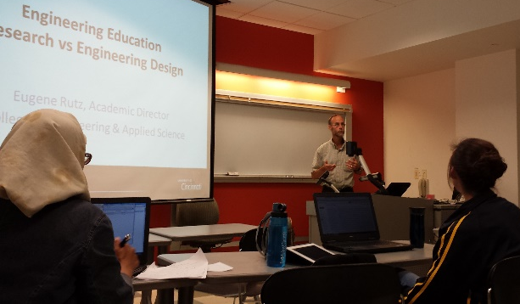
Figure 1: Eugene Rutz Compares Engineering Research Verses Engineering Design

