Draft Poster Evaluation Session (Speakers: Dr. Anant Kukreti and Ms. Debbie Liberi; Date: July 16; Time: 9:00-11:00 AM)
This session was conducted after the teachers had received poster creation training in the Engineering Foundations project, in which they created a poster for a course project. Additional training on creating a poster for the RET Unit (after teaching the Unit) was given as part of the Education PD Sessions from SIT. This session gave the teachers a chance to present first drafts of their posters, about two weeks prior to final presentation, for critique.

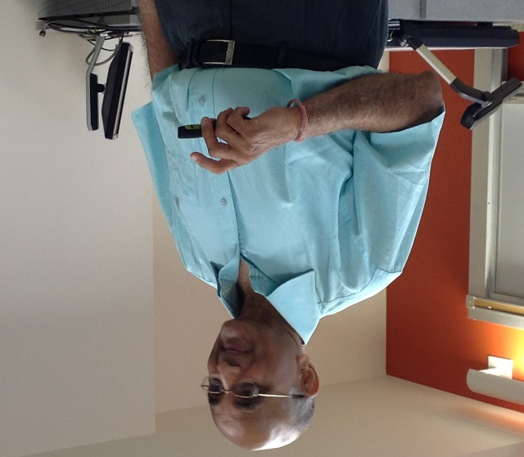
Figure 1: Dr. Kukreti Explaining Misconduct Versus Ethical Behavior
This session was presented by Mrs. Debbie Liberi and Dr. Anant Kukreti. Mrs. Debbie Liberi currently serves as the District Coordinator for the CEEMS grant at UC. She earned BA in Biology at Wittenberg University and a Masters in Secondary Educations from UC, as well as, a Masters in Library and Information Science from Kent State University. From 2000-2010, Debbie was a National Board Certified Teacher in Early Adolescence Science. She also served as a lead teacher in various mentoring roles for CPS.
Dr. Kukreti is Director for Engineering Outreach for the College of Engineering and Applied Science and Professor in the Department of Biomedical, Chemical and Environmental Engineering. He joined UC in August, 2000 as Head of the Department of Civil and Environmental Engineering (CEE).
Mrs. Liberi opened the session by reminding the participants that the purpose of the activity is to share progress on the research posters and to receive feedback. The posters are intended for the students and are to be in a three column format. The first column is to introduce the audience to the research conducted by the teachers as part of the RET program. The second column is to introduce students to challenge based learning and engineering design process and to bridge the research into the classroom. The third column is to stimulate the student’s curiosity by hinting to the unit that will be taught in the classroom. The floor was then opened to participants for poster presentation.
The RET teachers took turns displaying posters and receiving feedback from Dr. Kukreti, Mrs. Debbie Liberi, Mr. Steve Geresy, and fellow participants. The feedback given complemented positive aspects of each poster and provided suggestions for improvement. Presenters were encouraged to do the following: chose background colors that complement the images being displayed, select text color that contrasts with the background and is easily visible, reduce the amount of text and try to convey information with images, chose images that are eye catching, and to not give away too much information in regards to the Challenge that will be presented to students, instead use images to get the students thinking about the Big Idea the unit will cover. Detailed feedback was also provided to each presenter in an email from Mrs. Liberi and Mr. Geresy.
The session clarified the purpose of and expectations for the poster. Participants left the session with individualized feedback and a plan for improving the poster. A picture of the session of the teachers projecting their poster and receiving critique is presented in Figure 2.
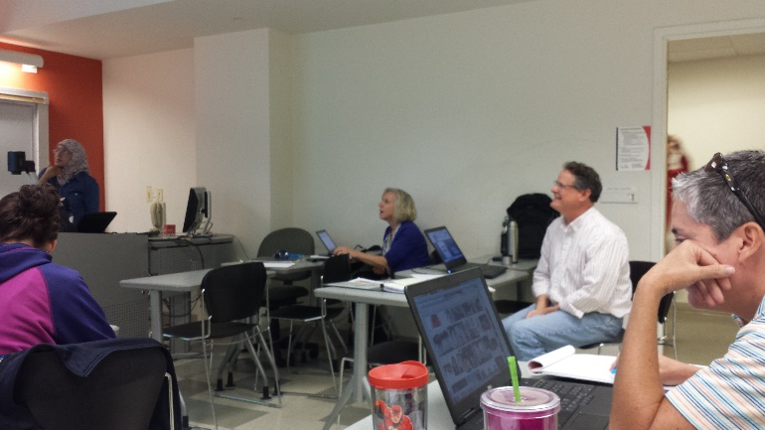
Figure 2: RET Teachers Present Posters and Receive Feedback from Dr. Kukreti, Ms. Debbie Liberi and Mr. Steve Geresy

