**Cooperative Learning** (Speakers: Ms. Valecia Kelly, 9th Grade Biology Teacher, Shroder Paideia High School, Cohort 2 CEEMS Teacher and Ms. Lori Cargile, Resource Team Member, CEEMS MSP and MAT Doctoral Student; Date: July 15; Time: 9:00-11:00 AM)

Ms. Valecia Kelly has taught science for 26 years with Cincinnati Public Schools. She currently teaches 9th grade Biology at Shroder Paideia High School where she also serves as the 9th Grade Team Leader, Building Rep and High School Coordinator for Minorities in Math Science and Engineering. Ms. Kelly earned a BS in Biology from McPherson College, and a Teaching Certificate from the College of Mount Saint Joseph. She is a participant in the first cohort of the STEM Leadership Academy sponsored by Battelle. In addition, Ms. Kelly is the Executive Director of Christ Emmanuel Christian Fellowship CDF Freedom School®.

Ms. Cargile is a graduate of Spelman College and also earned an MAT in Teaching from Emory University in Atlanta. She is currently a Curriculum and Instruction doctoral student at UC and is also a Resource Team Member for CEEMS MSP. She was a classroom teacher for 10 years and also served as a Lead Teacher for 4 years for Cincinnati Public Schools. Most recently, she was a middle school assistant principal for 4 years in the North College Hill School district.

This continuing education session focused on some of the many ways that cooperative learning can be developed in the classroom. Along with this, Ms. Kelly and Ms. Cargile made a point of differentiating between cooperative learning and group learning. The main method of engaging the participants in the lesson was through participation in a handful of cooperative learning activities.

The first cooperative learning exercise was a task where everyone in the class (approximately 40 people) were asked to put themselves into birth order, month and day only, without talking. The second task began almost immediately with Ms. Kelly using this line of people to pair the first two women into a group, the next two women, the next two men … until everyone was paired. She then handed out pieces of string approximately 6 feet long to each person with the instruction to loosely tie one end of the string around one wrist. The other end was crossed with the partner’s string and the free end tied loosely to the other wrist. The result was that each pair was “handcuffed” with the strings intertwined. Participants were then told to extract themselves from the entanglement without removing the loops around the wrists. **Figure 1** on next page shows a pair of teachers participating in this group activity.

Following about two minutes of struggle and no one able to extricate themselves, Ms. Kelly told the group it could be done and that she would give a hint after another 2 minutes. As promised, she shared that the trick to getting free was related to the wrists. Within a minute two groups had figured out how to release themselves. These first teams were given a ticket – much like those used in raffles or used at carnivals. Within a short period, groups were sharing their knowledge to assist others in freeing the pairs. When everyone was free, participants were given a playing card from a regular card deck and told to sit at a table with those with the same number. Instructions were given by Ms. Cargile now to work as a group to record what the keys were to working through the problem; what worked and what didn’t work. Ms. Cargile encouraged people to share with everyone what methods worked. When an individual

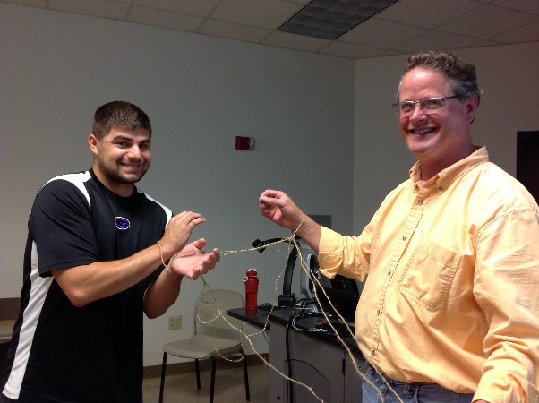

**Figure 1: Teachers Engage in a Team Building Activity**

shared, Ms. Kelly would hand that person a ticket. About this time, participants began to talk about what the raffle tickets might mean, what prizes might be given.

At this point, Ms. Kelly shared what she felt was the biggest take-away from this session and that was that Group Learning is not the same as Cooperative Learning.

Displayed on the projection screen was a graphic taken from Kagan’s Cooperative Learning methodology using the PIES mnemonic. Following points were stressed:

* Positive Interdependence – team work, divide the labor
* Individual Accountability – students turn in own answers, color code individual work
* Equal Participation – assign roles, participation by all
* Simultaneous Interaction – students share with partner, present to each other

A discussion about grouping followed with Ms. Cargile stating that she prefers to group science students in groups of four with their desks pushed together with pairs of students facing one another. In math classes, she prefers to have groups of three or four each group of students is lined up side-by-side and facing the front. Each grouping of tables separated from the other groups to allow the teacher to move about. Furthermore, she felt it best to seldom use homogenous groupings of students as they lack the varied ideas and opinions that come from heterogeneous groups which are preferred.

Heterogeneous groups can be formed randomly, by interest, by choice, by gender or by work habits. The key to group assignments was the need to be fluid and change them as needed, Ms. Cargile explained. She went on to explain that by giving a group grade on assignments, you are essentially giving the entire group the grade of the highest achieving student in that group.

To reinforce positive interdependence, Ms. Kelly wanted the groupings to have a team name or mascot. To help them choose, she had one member draw a circle in the middle of a blank piece of paper. From the circle they extended four lines starting at the outside of the circle to each of the four corners of the paper, as shown in **Figure 2** on next page. One person was directed to write their favorite color and the rest in the group were told to pass the paper and write their favorite color. In the next space, the first person was told to write their favorite food on the paper, again with the others doing the same. This was repeated for, what members did in their spare time and what kind of music they like to listen to. From the compiled lists on the sheet each group was told to come up a team name based on the information each person had written. Each group was called on to explain why they chose their particular name. Ms. Kelly suggested that team names be used to provide praise and feedback. She indicated that the principal give positive feedback to a team by using their team name during announcements.

To facilitate individual accountability, Ms. Kelly placed a red cup and green cup at each table. The bottoms of the cups were glued together and she explained that when a student didn’t understand a concept or directions, they should place the red cup above the green on the desk. When she would see



**Figure 2: Establishing Team Identity Diagram**

that “Ashley” had a question, she would say to an individual next to Ashley to find out what Ashley’s question is. Making this routine would lead to others in the class becoming the teacher or leader.

Another similar technique incorporated into Ms. Kelly’s classroom is the “Three Before Me” rule. This requires a student with a question to ask three other students before asking the teacher. This places the responsibility of learning back onto the student.

The individual accountability can be emphasized by having each student in a group take on a role. Groups are sometimes able to decide for themselves on role assignments, but the key is to have the roles rotate. Students are asked to submit their own copy of critical assignments and allowing “team time” to give students in a group a few minutes to collaborate before turning in their assignments is a way to encourage quality work.

A Chewy Lifesaver was placed on each groups’ desk with a cup inverted over it. On top of the inverted cup was placed a gummy worm. Four paperclips were also placed on the desks; one for each member. Groups were instructed to save Sam, the worm, from drowning by getting the life ring out from under the “boat” and putting Sam into the life ring. The groups had to do this without using our hands. Each group worked hard to accomplish the task and as the groups achieved the goal, each member was given another raffle ticket. Ms. Kelly again asked individuals to share how they were able to successfully achieve the goal. As they spoke, she gave them another raffle ticket.

Ms. Kelly suggested that collaborative work begin at the beginning of the school year with team building exercise like those she used in this professional development session because many students come to the classroom with little experience in working cooperatively.

As the session ended, Ms. Kelly had participants draw raffle tickets for prizes. The prizes were those items she used in the cooperative learning workshop such as the deck of cards for random grouping, Chewy Lifesavers and gummy worm, the strings used as handcuffs, and the red/green cups.