Best Practices for Student Engagement (Speaker: Mr. Tim Dugan, Resource Team Member for CEEMS MSP; Date: – June 25; Time: 1:00-3:00 PM)
Mr. Tim Dugan has been an educator for 33 years with the Princeton City Schools. For 28 years he taught Social Studies and was the Advanced Studies Coordinator. He has been an adjunct instructor at UC for EdTech, Classroom Management, and Social Studies methods, as well as a contracted consultant to an architectural firm building schools in a variety of districts.
Mr. Dugan introduced himself to the audience as a firm believer that “Good pedagogy is not unique to one content field.” He began with the topic of Student Engagement, and outlined the workshop as a way to discover new methods for implementing lessons to encourage student engagement and to formulate ideas on how to measure student engagement. He asked the audience for their own definitions of student engagement.
Mr. Dugan then asked the teachers to write a concept or idea that he/she was personally interested in, for example a hobby or sport. Then, the teacher was to also list a tool (such as a pencil or iPad). The teachers got into groups of 3 or 4 and were asked to combine no less than three and no more than five of the things together along with one tool. They were then given 10 minutes to discuss how they might create a lesson utilizing as many of the concepts. A teacher group discussing lesson ideas is shown in Figure 1.
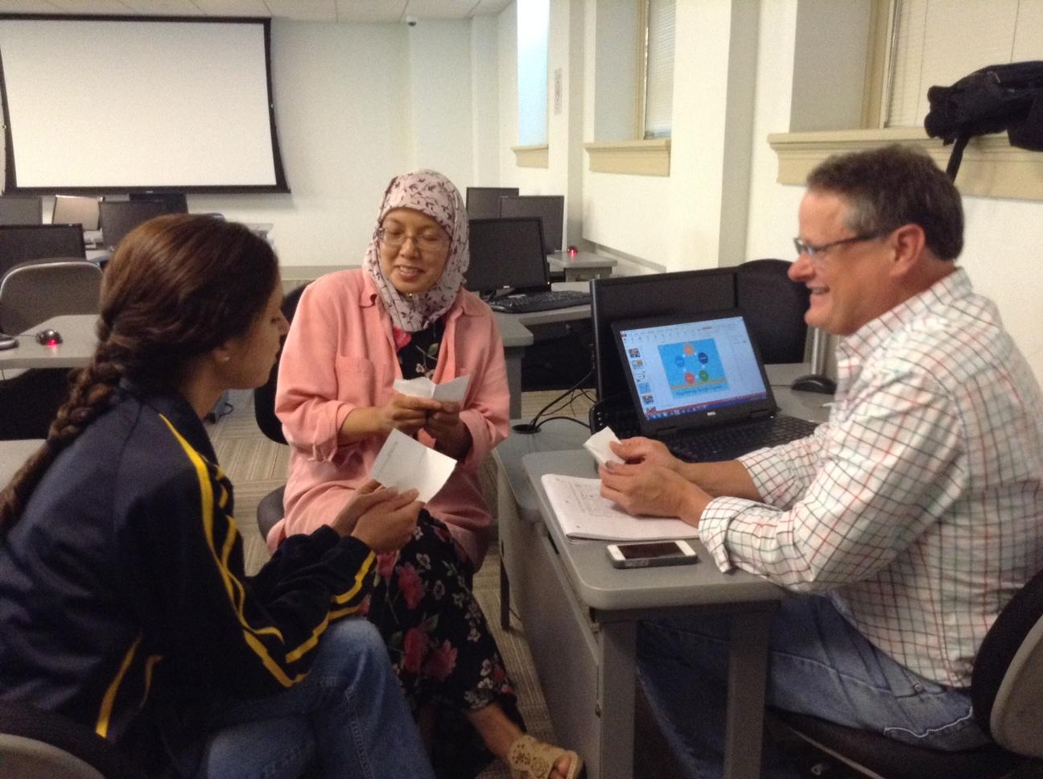
Figure 1: RET Teachers Cooperatively Discussing a Lesson Ideas
Each group presented their lessons. One group’s interests included: Star Trek, gardening, light, and camping. The tools they chose were: communicator, rototiller, flashlight, and an iPad. The lesson this group of teachers came up with involved a survivor theme. Students would be given the scenario of having landed to an unknown territory and would need to have a list of items they would need to survive and ultimately utilize to communicate for help.
The next part of the workshop referred the ASCD website, as well as to an article by Ben Johnson entitled “How Do We Know When Students Are Engaged?” (http://www.edutopia.org/blog/student-engagement-definition-ben-johnson) and a teacher rubric from the Boston Public School system addressing student engagement (http://www.bostonpublicschools.org/cms/lib07/MA01906464/Centricity/Domain/147/PriorityElementsLookfors.pdf). He addressed participation as: how many students on task. He noted that “participation is just step one.” Collaboration, achievement, as well as initiation, are all key to student engagement. In addition, Mr. Dugan reflected on how he was a merit scholar as a high school student and attributed this to his love for reading Marvel comic books since it required a high level of vocabulary. He emphasized that everything is connected, all subjects and that students can learn one subject even if addressing another.
At one point, Mr. Dugan had what he described as a “Schizophrenic moment” and asked his own audience how engaged they were. Teachers were to give feedback using their fingers – one held up represented not engaged, five fingers up represented very engaged. He reminded teachers to maintain an emotionally safe, intellectually safe classroom, and that they need to be sensitive to their students, especially if one of them is having a bad day, or just plain hungry. He uses incentives such as competition, donut holes, even an occasional dollar bill to keep his students motivated.
Mr. Tim Dugan’s presentation was funny, enthusiastic, exciting, and filled with helpful and inspiring anecdotes.

